RESOLUTION NO.__________

RE: CERTIFICATE OF APPROPRIATENESS UNDER THE
PROVISIONS OF THE ACT OF THE PENNSYLVANIA
LEGISLATURE 1961, JUNE 13, P.L. 282 (53
SECTION 8004) AND BETHLEHEM ORDINANCE NO.
3952 AS AMENDED.

WHEREAS, it is proposed to install new signs on the front of the building at 123 W. Fourth St.

NOW, THEREFORE, BE IT RESOLVED by the Council of the City of Bethlehem that a Certificate of Appropriateness is hereby granted for the work.

Sponsored by: (s)

(s)

ADOPTED BY COUNCIL THIS DAY OF

(s)
President of Council

ATTEST:

(s)
City Clerk

HISTORIC CONSERVATION COMMISSION

CASE # 507– It is proposed to install new signs on the front of the building at 123 W. Fourth St.
OWNER/APPLICANT: Jose & Rafaela Nunez / Jose Nunez & Darryl McElay

The Commission upon motion by Mr. Cornish seconded by Mr. Roeder adopted the proposal that City Council issue a Certificate of Appropriateness for the proposed work described herein:
- The proposal to install new signs on the front of the building at 123 W. Fourth St. was presented by Jose Nunez & Darryl McElay.
- The main sign will read “publik house” in yellow/gold lettering on a red/orange background with a border.
- A second, smaller sign will be located below the main sign and will read southside in the same colors and font.
- The signs will be fabricated of a durable plastic sign material.
- The proposed motion was unanimously approved.

CU: cu

By: 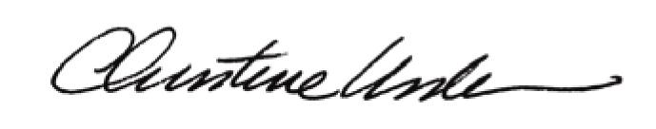

Date of Meeting: August 18, 2014 Title: Historic Officer

